Project Design Phase-II
Technology Stack (Architecture & Stack)
Date | 20 July 2026
Team ID
Project Name | Plugging Into the Future: An Exploration of Electricity Consumption Patterns
Maximum Marks | 4 Marks

Technical Architecture
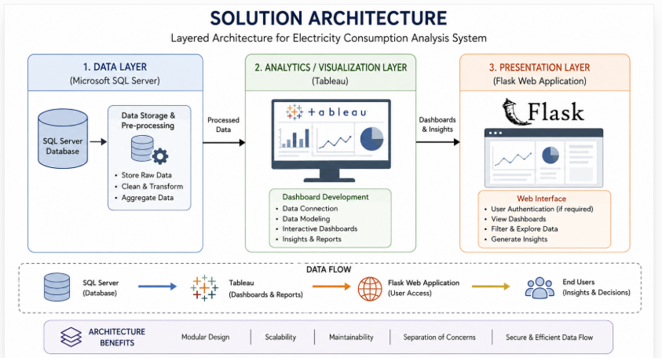

Table-1: Components & Technologies
S.No | Component | Description | Technology
1. | User Interface | How the user interacts with the application | HTML, CSS (served via Flask templates)
2. | Application Logic | Routing and page-serving logic | Python, Flask
3. | Database | Storage, cleaning, and querying of the dataset | Microsoft SQL Server, T-SQL
4. | Data Visualization | Dashboard and story creation | Tableau
5. | File Storage | Local storage of dataset/exports | Local filesystem
6. | External API | Not used in this project | N/A
7. | Machine Learning Model | Not used in this project | N/A
8. | Infrastructure | Application run locally during development | Local server (Flask dev server)

Table-2: Application Characteristics
S.No | Characteristics | Description | Technology
1. | Open-Source Frameworks | Web and visualization frameworks used | Flask, Tableau
2. | Security Implementations | Access to the database is restricted to the pipeline; no public write access | SQL Server access controls
3. | Scalable Architecture | Layered design: data, visualization, and presentation layers act independently | 3-tier architecture
4. | Availability | Application runs whenever the Flask server/dashboard is active | Flask dev server
5. | Performance | Pre-aggregated queries and Tableau extracts keep dashboards responsive | SQL Server indexing, Tableau extracts

